RETRAINING MOBILITY

OBJECTIVES
After this session the student should be able to:
- Carry out an objective assessment of lower limb function including gait
- Conduct training strategies to rehabilitate lower limb function including gait

ASSESSMENT
Using the task-oriented approach, based on the ICF categories (International categories of functioning, disabilities and health) mobility dysfunction should be assessed at three levels
- Functional (e.g. mobility disability in home and community environment)
- Strategies (including those required to achieve mobility)
- Underlying impairments (including sensory, motor and cognitive)

FUNCTIONAL ASSESSMENTS - OUTCOME MEASURES
These tests measure a person’s ability in his/her natural environment. The assessment can be observed or reported.
Examples (see Appendix) of functional measures for walking ability include:
- Gait velocity (6-meter walk test)
- Walking Endurance (6-minute walk test)
- Walking assessments
    - Timed up and go (TUG)
    - Dynamic Gait Index (DGI)

Students Activity 1
Practice conducting gait velocity assessment 6 – meter walk test and 6-minute walk tests.

GAIT ANALYSIS RECAP
- Stance: weight acceptance (loading), mid stance, terminal stance and pre-swing (push off)
- Swing: Initial swing (lift off), mid-swing, terminal swing (reach)

Students’ activity 2
Students recap on gait analysis:
- Kinematics (joint angles)
- Muscle activities
- Spatiotemporal characteristics
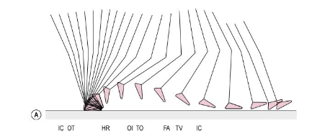

Position of the R leg in the sagittal plane at 40ms intervals during a single gait cycle.

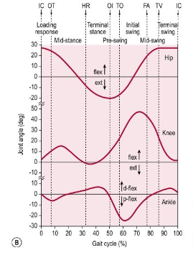
Sagittal plane joint angles during a single gait cycle.
Key: IC= initial contact; OT=opposite toe off; HR=heel rise; OI=opposite initial contact; TO=toe off; FA=feet adjacent; TV= tibial vertical

STRATEGY ASSESSMENTS (gait analysis)

Tutor demonstrates a gait assessment of patient presented in Gait video 1

Observed Abnormalities | Possible causes

Students Activity 3
Conduct a gait analysis of the patient in the video clip provided.

Observed Abnormalities | Possible causes

IMPAIRMENT ASSESSMENT
- Musculoskeletal and Neuromuscular factors
  - Tests for lower limb passive range of motion

- Strength
  - Tests to measure lower limb muscle strength including hip, knee and ankle

- Spasticity (demonstrate spasticity tests)
  - Assess spasticity in the knee extensors and ankle plantar flexors using the Modified Ashworth Scale.

- Sensation (demonstrate sensation tests)
  - Test light touch, proprioception, two-point discrimination, stereognosis and pain or temperature.

TRAINING GAIT

- Research findings
- ↓ self-directed and maximum speed
- ↓ magnitude of flexion/extension joint angle range in both lower limbs
- ↓ hip extension at the end of stance
- ↑ double support phase
- ↓ vertical reaction force at push off
- ↓ power generation at the ankle for push off and at the hip for pull off
- ↓ endurance
- ↓ adaptability to changing environmental conditions.

- Contributors to walking dysfunction
- Muscle weakness
- ↑intrinsic muscle stiffness
- Disordered motor control
  - ↓ speed of activation
  - ↓ peak muscle contraction
  - slowness in reaching peak amplitude of force
- Soft tissue contracture
- Feelings of instability or unsteadiness

- Contents of gait training
  - Treadmill and overground walking
  - Exercise to increase strength and control of lower limb muscles
  - Activities to preserve muscle extensibility.
  - Training to maximise skill, speed, endurance and fitness

- Key focus in training gait
  - 10-15⁰ hip extension of the paretic limb in late stance (provides mechanical advantage to hip flexion for power generation for pull off
  - Plantarflexion at the ankle at the end of stance for push-off
  - Flexion at the hip for pull off.

Possible treatments
- Muscle strengthening strategies
  - Ankle plantarflexors & dorsiflexors (heel raise and lower from a step)
  - Hip, knee and ankle extensors (step up and down; sit to stand; squatting)
  - Hip abductors

Training Parameters:
- Grade the amount of resistance and number of reps to individual ability
- Body weight, free weights, elastic bands
- Vary body weight resistance by changing step height, chair height, weight of object lifted
- General rule, three sets of 10 repetitions.
- For weak muscles, use methods which facilitate muscle activation and force generation e.g. simple exercises, force biofeedback, mental practice and functional electrical stimulation.

- Flexibility strategies (hip flexors and plantarflexors)
  - Active stretch
  - Passive stretch

- Activating paretic muscles
  - Ankle dorsiflexors
  - Ankle plantar flexors
  - Knee flexors
  - Knee extensors
  - Hip extensors

- Gait Training
  - Loading Paretic Limb – standing up, sitting down, stepping to a step
  - Treadmill Walking/ Overground walking – gait initiation
  - Backward walking /sideways walking

- Maximising skill, speed and endurance
    - Increase speed (1.1 -1.5m/s)
    - Increase walking distance (about 500m)
    - Turning head while walking
    - Quick reaction to slips, trips and avoid a fall by stepping
    - Negotiate stairs, kerbs, ramps, moving footways and carry object

- Walking aids/orthoses
  - Ankle Foot Orthoses
  - Functional Electrical Stimulation (FES)

ANKLE FOOT ORTHOSES

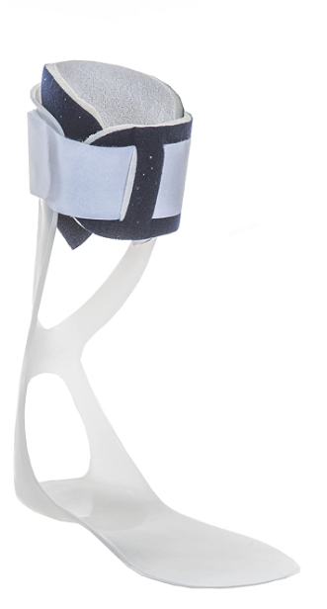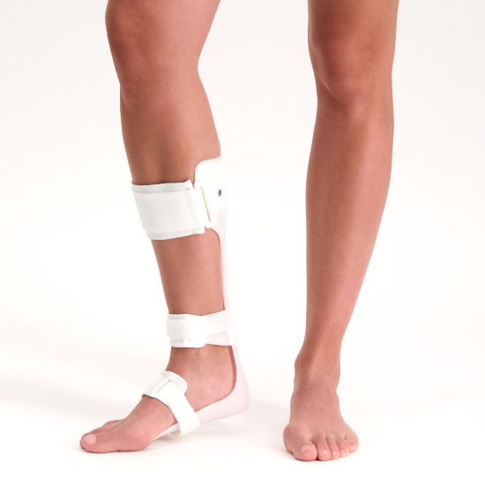

Functional Electrical Stimulation

https://youtu.be/u1JpHWog3R4

References
Carr, J. H. and Shepherd, R. B. (2010) Walking – chapter in Neurological rehabilitation: optimizing motor performance. 2nd edition. St. Louis: Churchill Livingstone Elsevier page 95 -122. http://www.vlebooks.com/vleweb/product/openreader?id=LondonMetr&amp;isbn=9780702044472.

